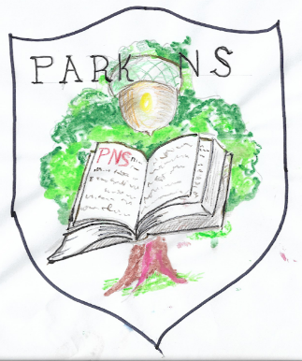  “Great oaks from little acorns grow” | Park National School,  Park, Youghal, Co. Cork
Tel: 024 97282
email:parkschool.ias@eircom.net
www.parkns.ie

2nd Class Book list
 | Price (€) | Tick if required
Workbooks
Grammar 2 pupil book (Jolly phonics) | 6.45
All write now cursive Level B (Folens) | 7.15
Grow in Love First Class (Veritas) | 9.50
Planet Maths Second Class book (Folens) | 15.20
Planet Maths Second Class satellite book (Folens) | 7.10
New wave Mental Maths – Second Class (Prim Ed) | 8.00
Explore with me First class (Edco) | 10.95
Bua na Cainte 2 (Edco) | 11.95
Am don léamh – Rang a dó (Folens) | 7.60
Ceartlitriú 2 (CJ Fallon) | 9.45
Copies - covered where possible in plastic to prevent wear
Homework Journal – Hardback | 3.50
2 x Notebook 48pg (has a plastic cover) | 1.00 each
1 x Learn to write b4 handwriting copy (has a plastic cover) | 60c
2 x Nature study copy (has a plastic cover) | 60c each
5 x 88page copy * | 40c each
2 x Sum copy (C3) * | 40c each
5pk copybook covers (for copies with *) | 1.30 per pack
1 x A4 Mesh storage wallet | 2.50
1 x A4 plastic storage folder | 1.00
1 x Music folder – 40 pocket display folder A4 (continue from 1st) | 4.00
2 x Scrapbook | 2.50 each
1 x D Tin Whistle | 5.50
Stationery - all clearly labelled
Pencils, rubber, sharpener, pen, colours | n/a
1 x ruler | 1.00
2 x glue sticks | 4.75
Total: ______________
Child's name: _________________________

