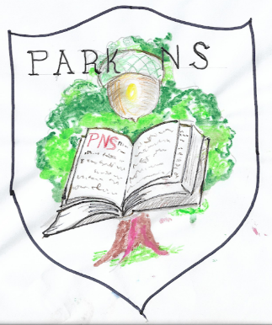  “Great oaks from little acorns grow” | Park National School,  Park, Youghal, Co. Cork
Tel: 024 97282
email:parkschool.ias@eircom.net
www.parkns.ie

Senior Infant Book list – Ms. Bulman
 | Price (€) | Tick if required
Workbooks
Sounds in Action – Senior Infants (Folens) | 7.70
All write now – Senior Infants (Folens) | 5.75
Phonics pupil book 2 (Jolly phonics) (Black & White version) | 2.95
Grow in Love Senior Infants – (Veritas) | 9.50
Bua na Cainte B (Edco) | 9.95
Planet Maths Senior Infants (Folens) | 12.10
Copies
2 x project copy 15A (40pg) | 60c each
2 x B2 learn to write exercise book (40pg) | 60c each
2 x Blank/Plain Day copy (40pg) | 60c each
1 x Junior sum copy – 20mm squares | 60c
2 x scrapbook (57986) | 2.50 each
1 x A4 mesh storage wallet | 2.50
2 x A4 plastic document wallet | 1.00 each
Stationery - all clearly labelled
Junior grip triangular pencil x 3, twin hole sharpener, rubber | 3.50
Twistables (price is for 12pk Crayola) | 4.50
2 x glue sticks | 4.75
Total: _______________

Child's name: _______________________________

