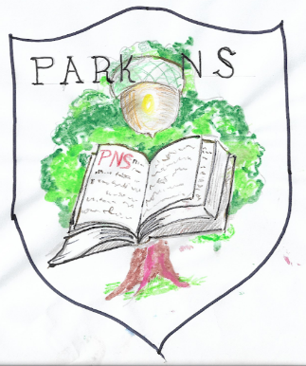 | Park National School,  “Great oaks from little acorns grow”  Park, Youghal, Co. Cork  Tel: 024 97282 email:parknationalschool@gmail.com www.parkns.ie

Heath and Safety Statement on General Policy
The Board of Management, Park NS, Park, Youghal, Co. Cork accepts its responsibility under the Safety, Health and Welfare at Work Act, 2005. This safety statement sets out the safety policy of the Board of Management, park N.S, and sets out the means to comply with this policy. The Board of Management's objective is to endeavour to provide a safe and healthy work environment for all our Staff Members and pupils and to meet our duties to members of the public with whom we come in contact. Co-operation will be expected and forthcoming from all school staff. The Board also aims to make Park N.S a safe place for all users of the facilities of the school. Should anyone consider that a hazard or important issue has not been dealt with or dealt with appropriately, he/she should bring the issue/hazard to the attention of the appropriate person (Patrick Curran safety officer BOM, Park N.S). It is our intention to undertake annual reviews of the statement in light of experience, changes in legal requirements and operational changes. The Board of Management undertakes to carry out regular reviews of Safety in consultation with staff, particularly Principal Orla Burke and Health and Safety representative from the staff Ms. O Grady. The inspection/safety audit will be carried out more frequently if requested by either staff or the Board of Management. All records of inspection reports and accidents will be monitored in order to ensure that any safety measures required can be put in place, wherever possible, to minimise the recurrence of such accidents and ill-health.

Patrick Curran :Chairperson, Board of Management. Date:9/11/’21
Principal: Orla Burke

